How to Use eWallet

Start by clicking on “Sign Up” in the eWallet section of the Home Page (www.bookwormcentral.com)
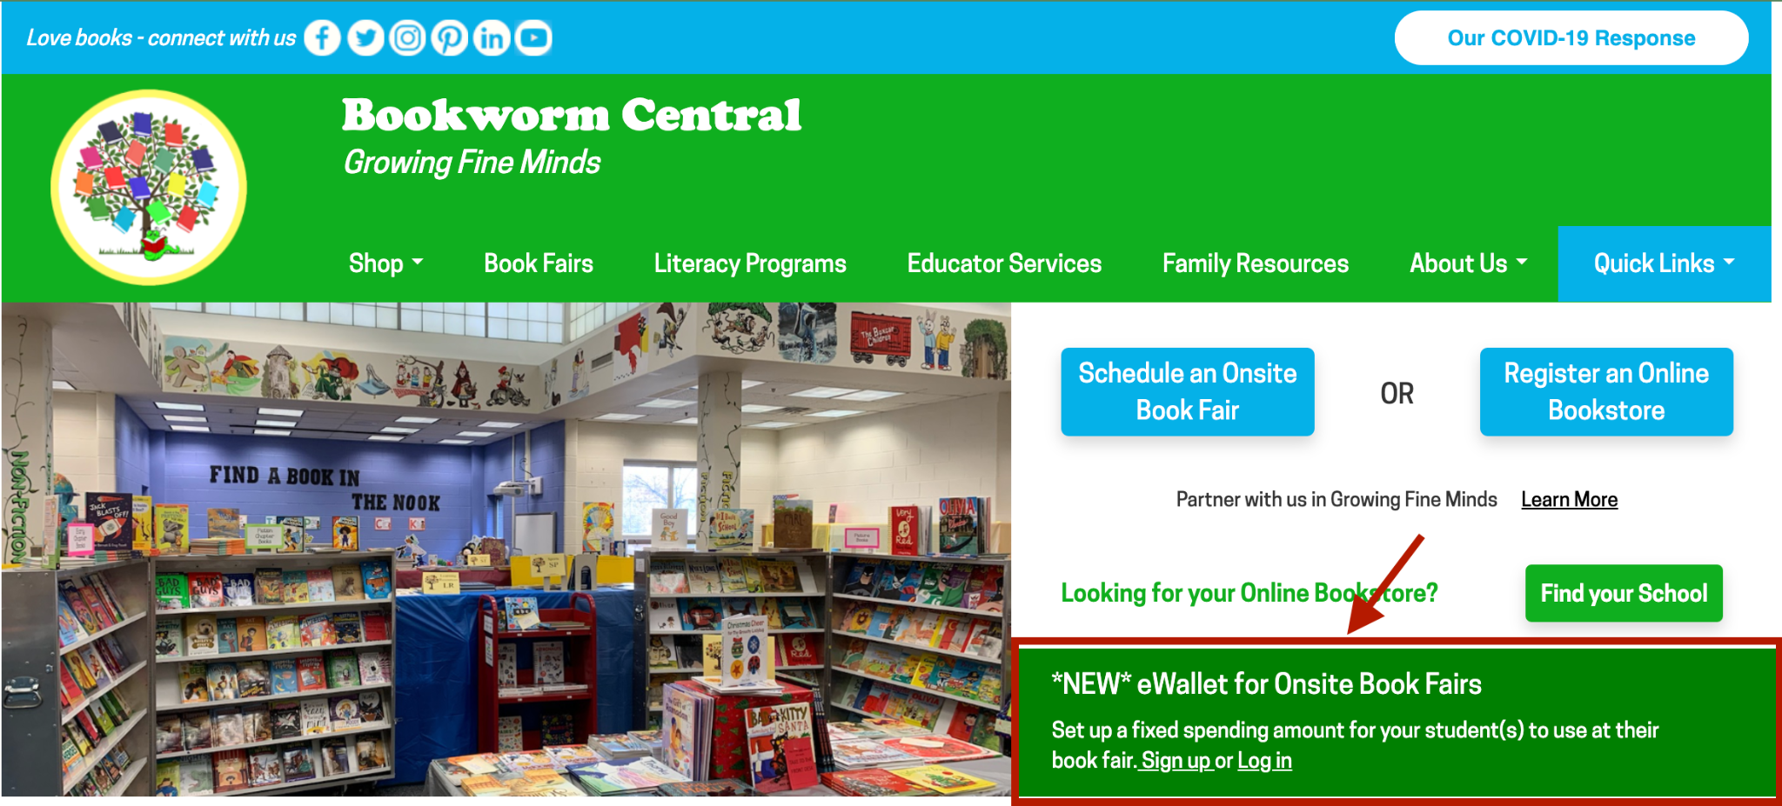
- Sign up by clicking on “Register”
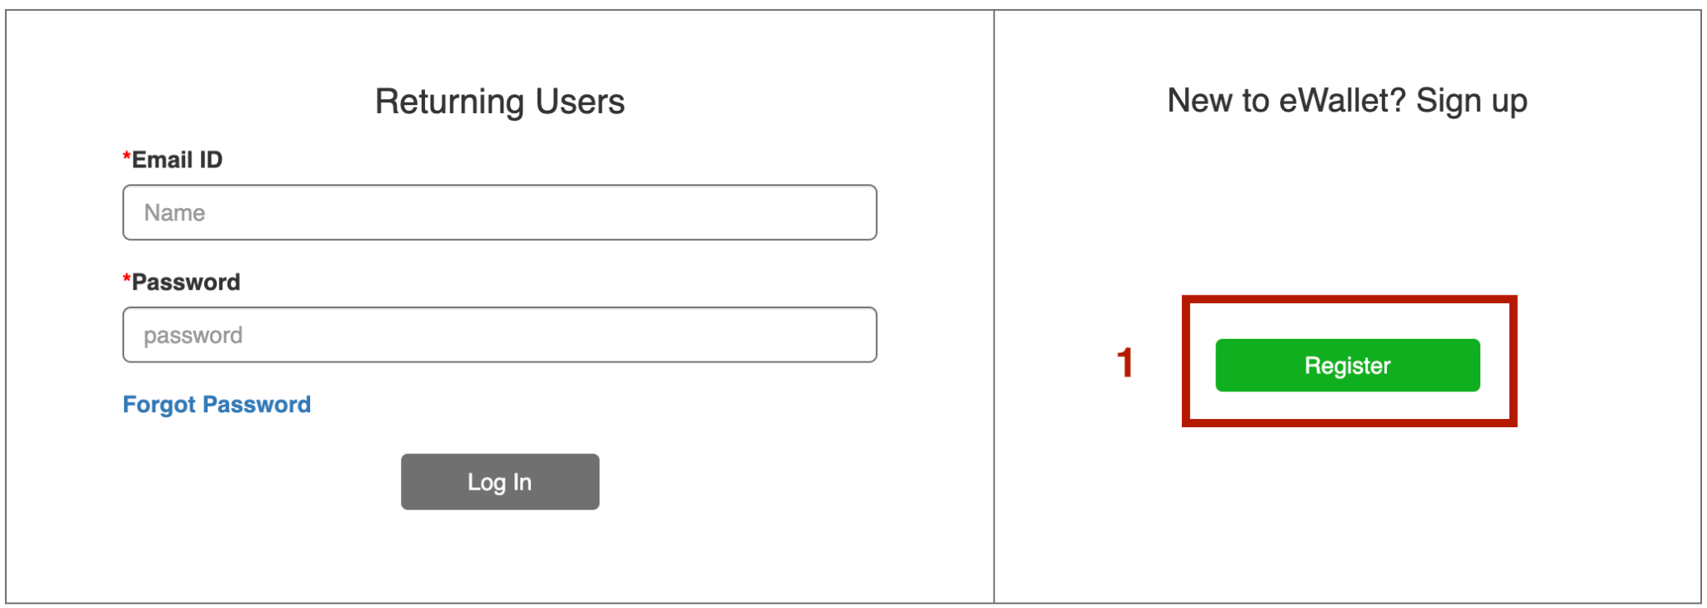
- Fill out your name, phone, email, and create a password.
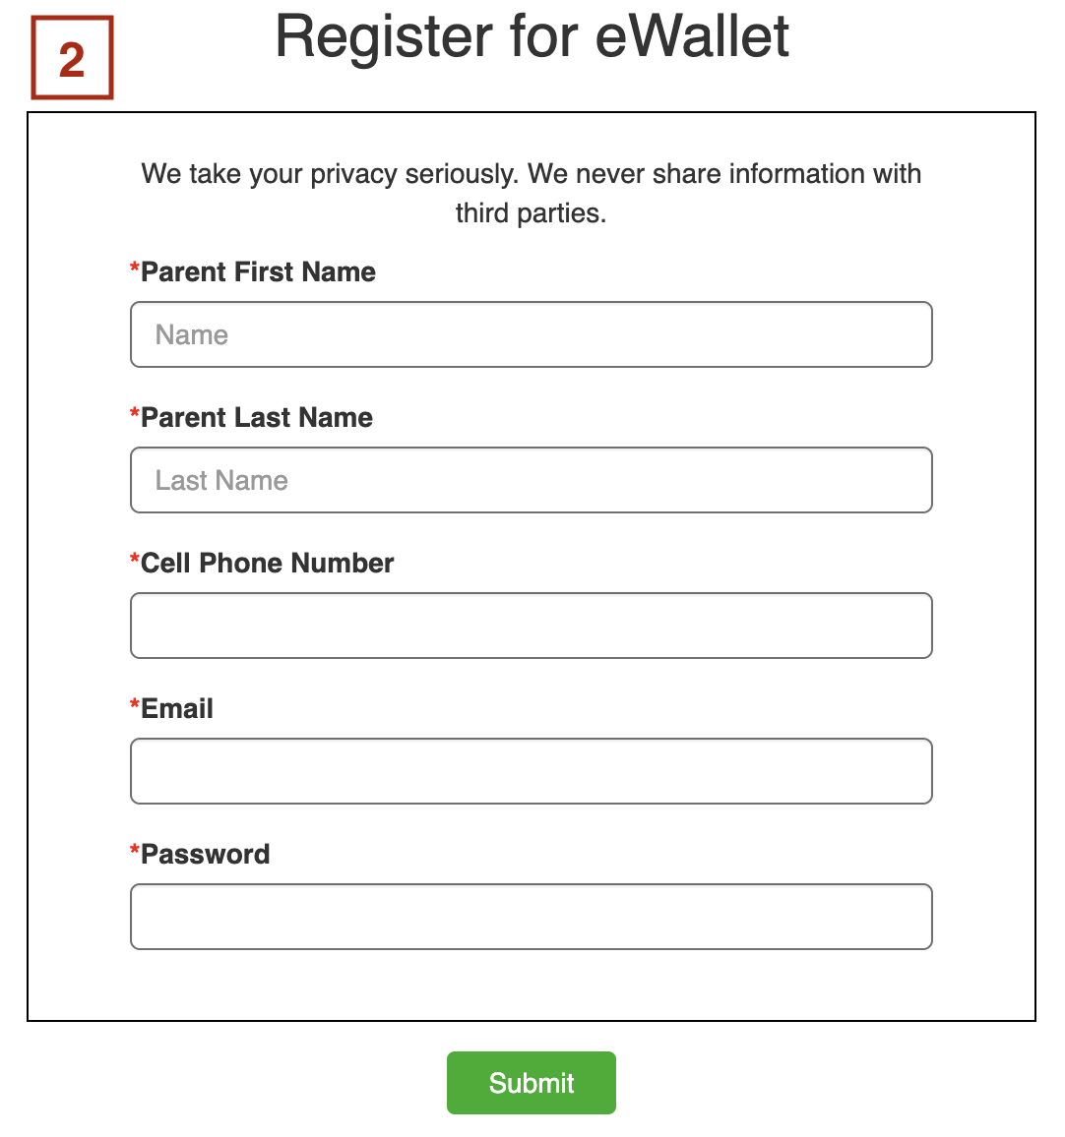
- Add a student to the account, by filling out the student name, school, grade, teacher, and the maximum amount to spend*. Click “Add Student”.
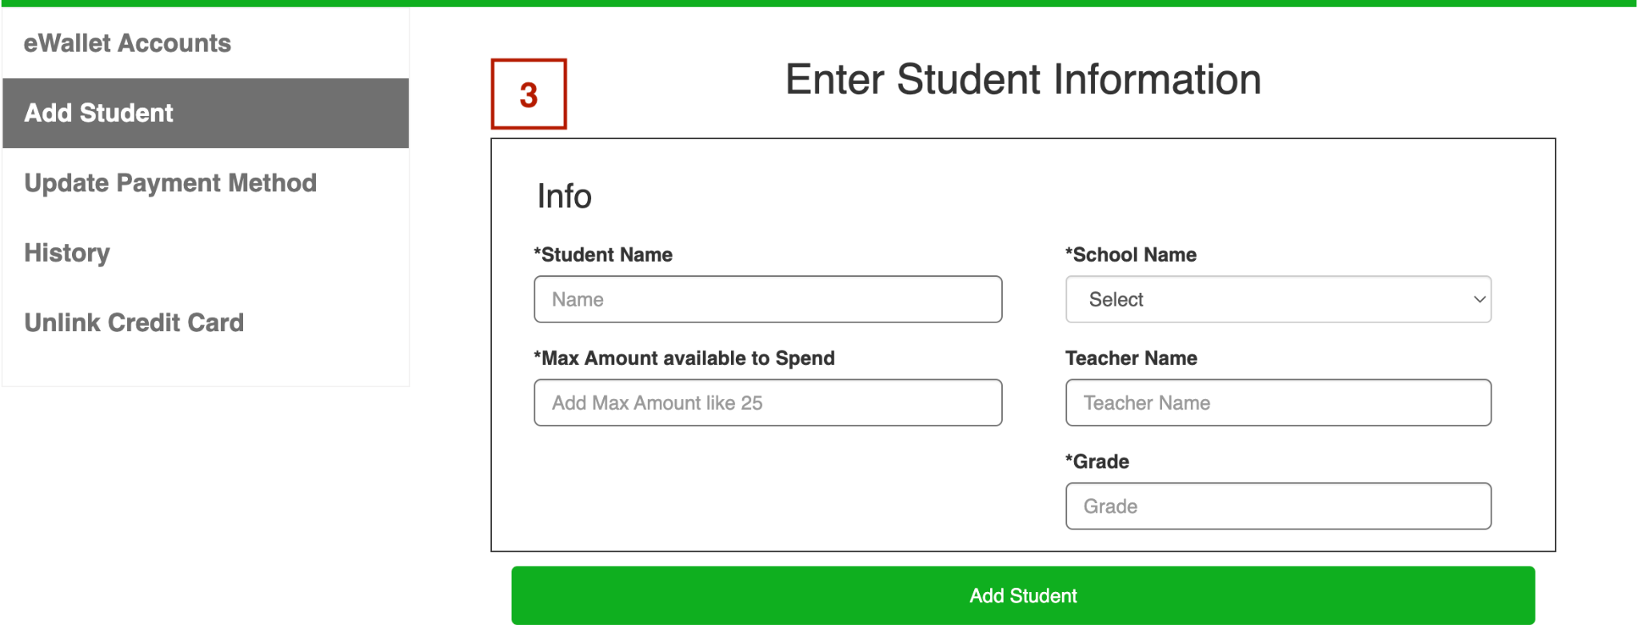
- Click “Add/Update Credit Card Details”.
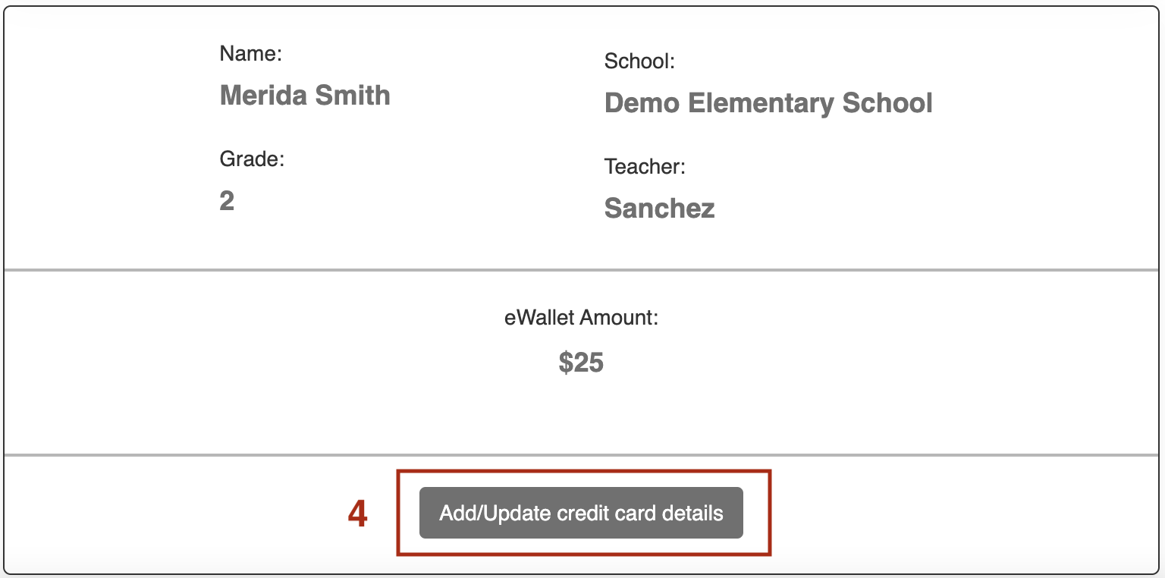
- Enter your credit card information and click “Pay” to continue*.

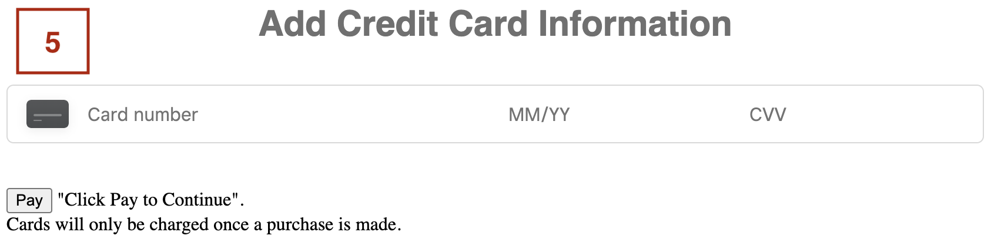
*Your card will NOT be charged until a purchase has been made. Only the amount purchased will be charged, not the maximum amount.
- If you have multiple students, repeat steps 3-5 until all students are added.
- When finished, click on Print eWallet.
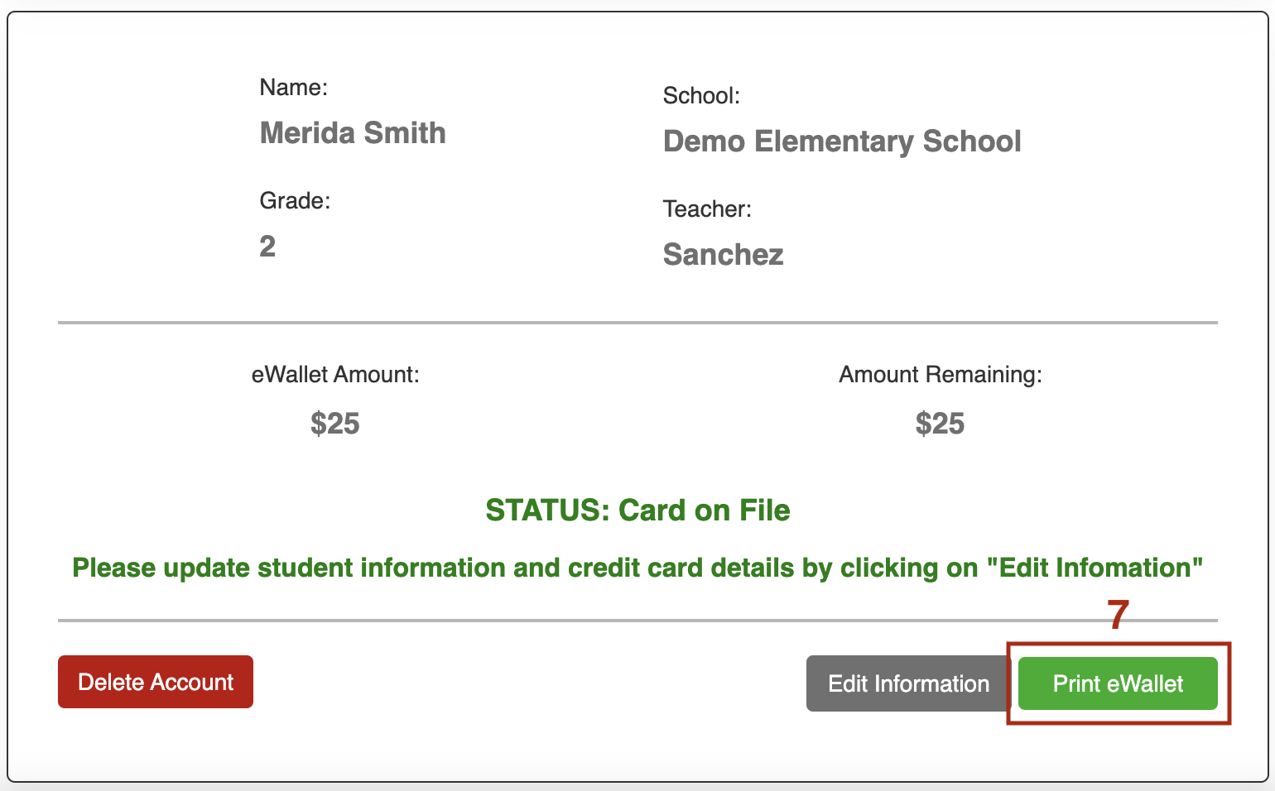
- Print out the eWallet to give to your student. Repeat for each student.
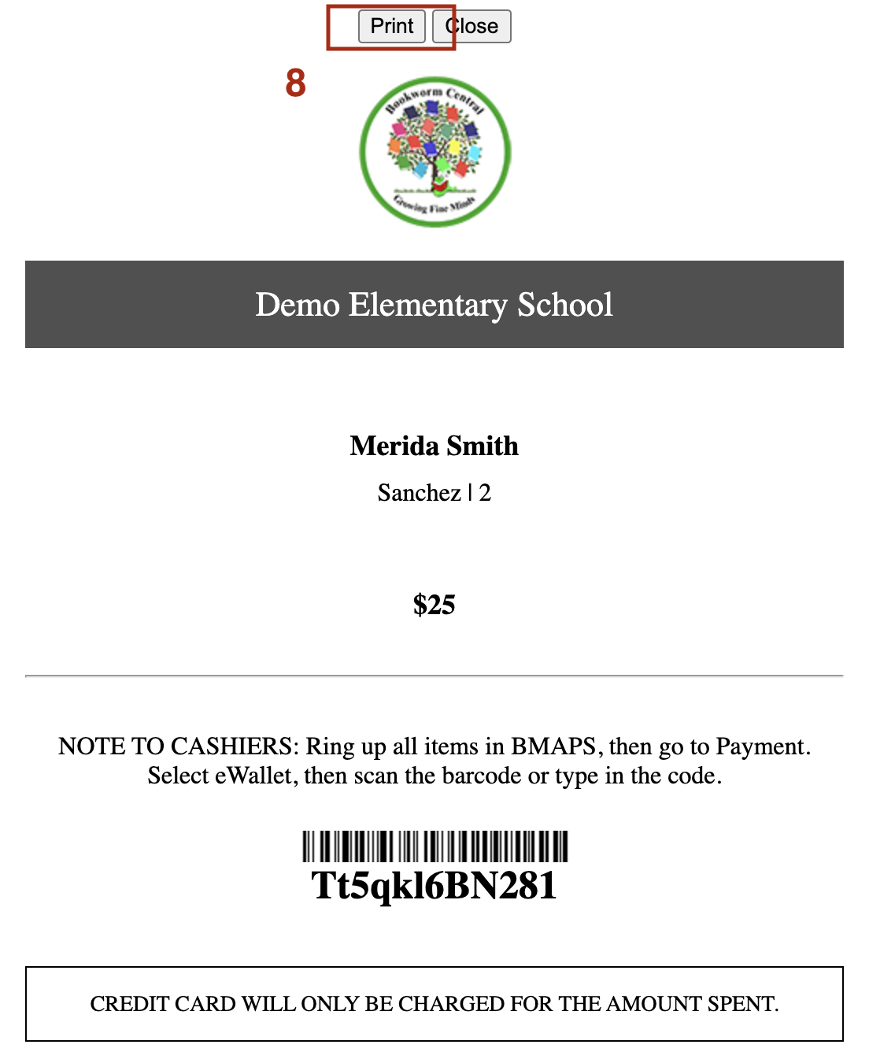

Other Features

History: allows you to see purchase history:
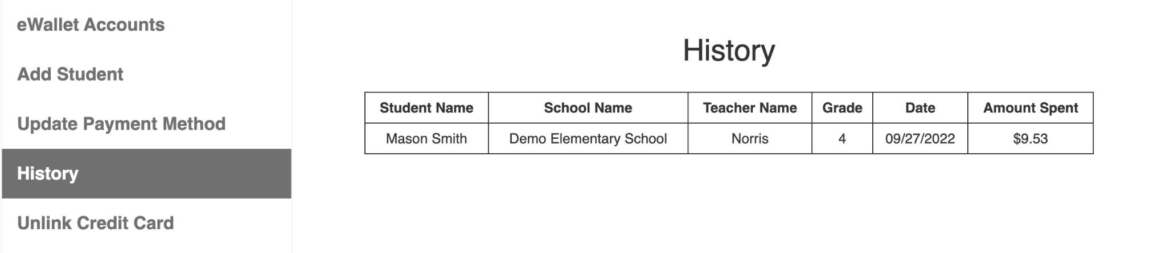

Unlink Credit Card: when you no longer wish to have your credit card tied to an account, you can unlink it from a student account.

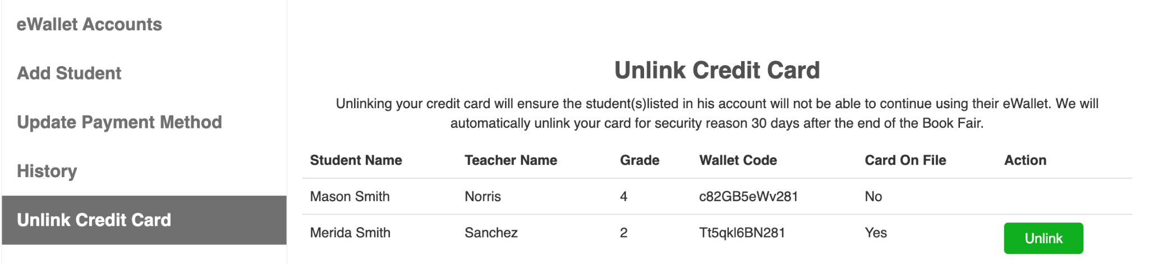

You can add the maximum amount of a student’s eWallet by going to “Edit Information” and entering how much you want to add to their account. Click “Update” when finished.

